Pro Power Onboard Chime – CGEA1.3

Functional Description

Pro Power Onboard chime is used to notify the user of the predefined value of Range Preservation Setting (RPS) and avoid user to face Low SOC situations.

When the RPS value is reached, the customer shall be notified with audible chimes along with the pop-up notification on the SYNC screen. While the customer is away from the vehicle working on the PPO feature, they may not have a chance to look at the SYNC screen. Audible chimes along with pop up will enable the user to recognize the situation and reset the RPS value. This STSS only takes care chimes, SYNC screen warnings are not in scope of this STSS.

The Pro Power Onboard Chime feature correlates the DcacChime_D_Rq Signal and the Operational Mode to generate the Message Center Chimes, which will be used by the chime arbitrator.

Interfaces

Interface Context Diagram (I/O Block Diagram)
Pro Power Onboard Chime Context Diagram

Inputs

IR-REQ-401066/A-Internal

Operational_Mode

MUX messages on the CAN Bus

SIG-REQ-401063/A-DcacChime_D_Rq Signal

Signal Name | Size (bits) | Detail | Units | Res. | Offset | State Encoded | Min | Max
DcacChime_D_Rq | 2 |  | SED | 1 | 0 |  | 0 (0x0) | 3  (0x3)
DcacChime_D_Rq |  | Off |  |  |  | 0x0
DcacChime_D_Rq |  | Information Chime |  |  |  | 0x1
DcacChime_D_Rq |  | SoftChime |  |  |  | 0x2
DcacChime_D_Rq |  | NotUsed_1 |  |  |  | 0x3

IR-REQ-401069/A-Outputs
- Message_Center_Informational_Chime_Status_Flag
- Message_Center_Soft_Warning_Chime_Status_Flag

Function/Performance

F-REQ-401068/A-Operational Modes

Mode | Differentiating Vehicle Conditions
Sleep Mode | Off
Limited Mode | Off / On
Normal Mode | Off / On
Crank Mode | Off / On

Voltage Levels

Refer to Cluster Features Table located in Operational Modes and Voltage Range Strategies section in this SPSS.

Human-Machine Interface

Visual

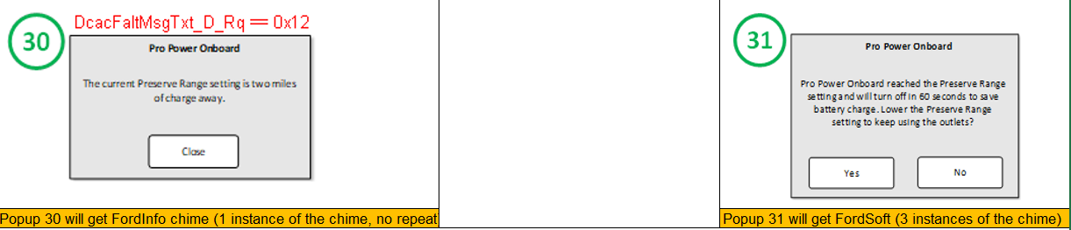

These Popups will be displayed on SYNC display and added here only for reference.

Audio

Refer to Audio Section in Chimes & Chime Arbitrator SPSS Section

Switch Control Logic

Not Applicable.

System Accuracy

PFM-REQ-401065/A-State Change
The state of this chime flag shall change within 100 msec of a state change as indicated in the state matrix found in section 1.3.5.1 of this document

Reference
Refer to System Accuracy in Chimes & Chime Arbitrator SPSS Section

Operation: Performance and Functional

Subsystem Algorithm Flowchart / State Diagram

F-REQ-401064/A-State Matrix for Pro Power Onboard Chime

Operational _Mode | DcacChime_D_Rq | Message_Center_  Informational_Chime_  Status_Flag | Message_Center_Soft_  Warning_Chime_  Status_Flag
Normal  or Crank  or Limited | 0x1  (Information Chime) | 0x1 (Active) | 0x0 (Inactive)
Normal  or Crank  or Limited | 0x2  (SoftChime) | 0x0 (Inactive) | 0x1 (Active)
All Other Cases |  | 0x0 (Inactive) | 0x0 (Inactive)

Operation Description (supports algorithm flowchart /state diagram)
None

FS-REQ-401070/A-Function Safety Classification (EMC)

B

NVM-REQ-401067/A-Memory Storage

Parameter Name | Description | Value at Battery connect | Value at  Module Wake-up
Message_Center_Informational_Chime_Status_Flag | State indicator for the chime | 0x0 (Inactive) | 0x0 (Inactive)
Message_Center_Soft_Warning_Chime_Status_Flag | State indicator for the chime | 0x0 (Inactive) | 0x0 (Inactive)
DcacChime_D_Rq Signal | CAN Signal | 0x0 (Off) | 0x0 (Off)
Operational_Mode | 4 State indicator for cluster operational mode | Limited | Limited or Normal or Crank

Prove Out

No

Reconfigurable Telltale

No

Message Center Msg

No

Error Handling

Missing Message Strategy

None.

Diagnostics

Self Test

None

Engineering Test Mode

Reference
Reference section “Dealer / Engineering Test Mode (ETM)”

Part II Performance

DID $DExx

None

Supported Diagnostic Trouble Codes (DTCs)
None

Reference Specification

None

Revision History

SPSS Module Revision History

Revision Level | Name | Change Description | Date
1.0 | H. Sharma | This request was brought to DICC by Shreeram Makki and approved for new STSS creation by Scott Watkins on 10/01/2020.  Lead Program: P702 BEV  DICC Tracking # 623 | 10/13/2020

